**8 SCIENCE ASSIGNMENT 2016**

THE ALCHEMISTS

**MARKING KEY**

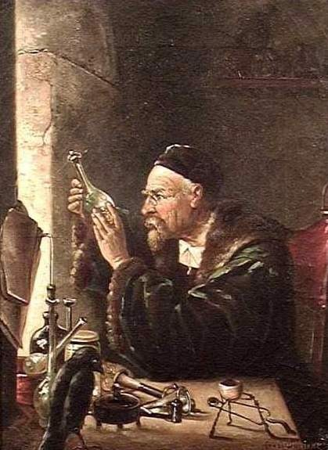

Name:__________________ Teacher:__________________

Form:__________________ Due date:_________________

1. State where the word ‘alchemy’ originates from and explain what the word means. (2 marks)

**The word ‘alchemy’ comes from the Arabic word Alkimia (1) and means the ‘art of transformation’ (1).**

2. Alchemists studied physical and chemical change by trial and error rather than using scientific method.

Explain what this means. (2 marks)

**Alchemists repeated the same process over and over again (1) whereas scientific method involves the use of a hypothesis, discussion and conclusion so the experiment can be repeated and altered (1).**

3. Alchemists tried to change metals from one type to another. Outline which specific metals they were trying to change and what they were hoping they would change into. (2 mark)

**Lead into gold and silver.**

4. Alchemists tried to discover the panacea, universal solvent, and the elixir of life. Describe what each of these were. (Minimum of two sentences each). (6 marks)

Panacea: **a single medicine that would cure all diseases.**

Universal solvent: **a liquid that could dissolve anything.**

Elixir of life: **mythical potion that grants drinker eternal life and/or eternal youth.**

5. The Philosopher’s Stone is one of the most well-known myths of the alchemists. Describe what the Philosopher’s Stone was and why it was one of the most sought after objects by alchemists in Europe. (Write in full sentences). (3 marks)

**Was a substance (sometimes believed to be a powder, liquid or solid). (1).**

**Any two of reasons below, one mark each (2)**

**It was believed to have the ability to change lead into gold.**

**Could give ultimate wisdom.**

**Could give eternal life.**

6. Western alchemists used symbols to represent the four Greek elements. State the four elements and draw their symbol next to each one. (8 marks)

**1 mark for each correct label and diagram.**

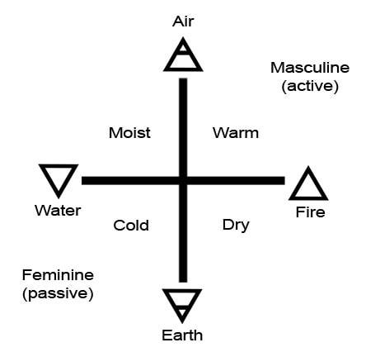



7. Explain one key difference between alchemy and modern science. (2 marks)

(Minimum of two sentences).

**Alchemy did not make use of scientific method (1) whereas modern science does make use of scientific method (1).**

**Alchemy used practices related to mythology, magic, religion and spirituality (1) whereas modern science makes use of how elements and compounds react and why (1).**

**(Or a similar response).**

 Jan Baptist van Helmont

Date of birth: **12 January 1580**

Place of birth: **Brussels, Southern Netherlands.**

Date of death: **30 December 1644**

Brief biography: look for four (4) pieces of information, one mark for each piece.

Such as: **he had four siblings and was the youngest child, he was educated at Leuven, he travelled through Italy, France, Germany, England and Switzerland, he obtained his doctoral degree in medicine in 1609, he married Margaret van Ranst in 1609.**

How alchemist contributed to science: **Jan Baptist contributed to the idea that digestion was aided by some sort of chemical (we now know there are enzymes that work on digesting food).**

 John Dee

Date of birth: **13 July 1527**

Place of birth: **London.**

Date of death: **December 1608 or March 1609**

Brief biography: look for four (4) pieces of information, one mark for each piece.

Such as: **Dee married three times and had eight children, etc.**

How alchemist contributed to science: **various responses.**

 Muhammad ibn Zakariyā Rāzī

Date of birth: **854 CE**

Place of birth: **Rey, Iran.**

Date of death: **932 or 925 CE**

Brief biography: look for four (4) pieces of information, one mark for each piece.

Such as: **Razi moved to Baghdad when young and studied and practiced at the local hospital, etc.**

How alchemist contributed to science: **various responses.**